1.Create a blank file named "myfile"

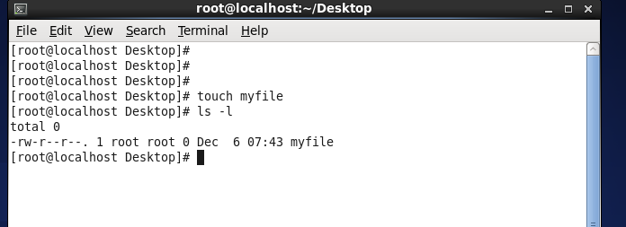

2. Open "myfile" in vi editor

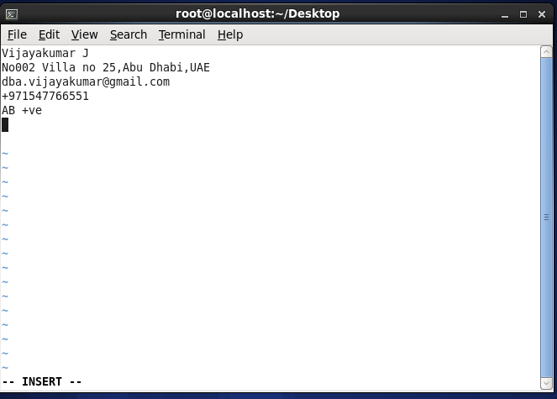

3. Write your name, address, email id, phone number and blood group in 5 different lines

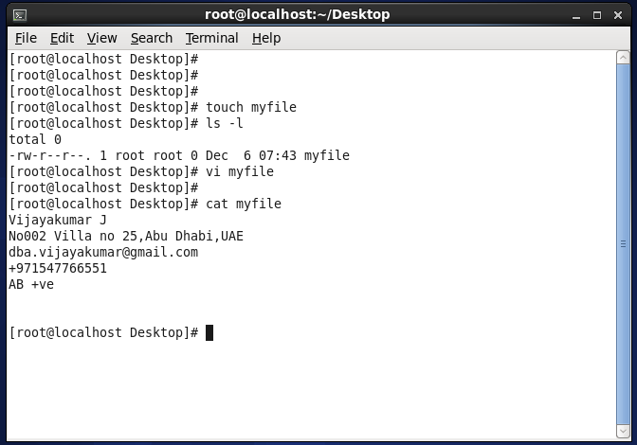

4.Build one single expression to see the line with your name and blood group in myfile

